1. A Boolean value is either true or false. It is named after the British mathematician, George Boole, who first formulated Boolean algebra — some rules for reasoning about and combining these values. This is the basis of all modern computer logic. In Python, the two Boolean values are True and False

- 5==9 => false

- 4!=3 => true

- 4-1==1=> false

2. Control flow is often easy to visualize and understand if we draw a flowchart. This shows the exact steps and logic of how the for statement executes

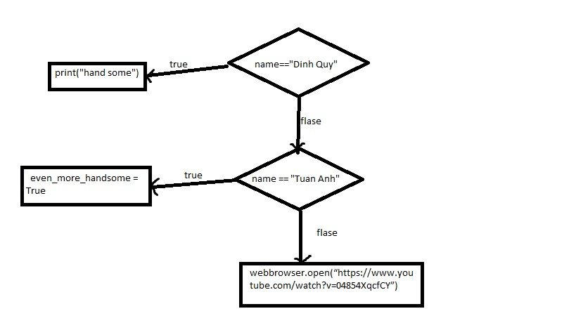

3. One conditional can also be nested within another.

if n%2 == 0:

if n > 1000:

print(“số chẵn và lớn hơn 1000”)

else:

print(“số chẵn nhỏ hơn hoặc bằng 1000”)